Modeling the Evolution of Global AI Competitiveness and Strategic Investment Optimization
Summary
Against the backdrop of the Fourth Industrial Revolution driven by Generative Artificial Intelligence (GenAI), establishing a scientific evaluation framework for global competitiveness is paramount for national strategic planning. This paper develops a multi-stage modeling framework by integrating statistical forecasting algorithms with non-linear programming theory.
For Problem 1: Indicator Identification and Interaction Analysis, we identify 19 core indicators spanning five dimensions: talent, scientific research, infrastructure, economy, and policy. To address the pronounced "long-tail effect" and ranking gaps caused by extreme outliers in the AI sector, we propose an innovative Sigmoid Non-linear Normalization method and employ the Entropy Weight Method (EWM) to determine objective weights. Pearson Correlation Analysis reveals a "Computing Power-Capital" double-helix driving mechanism ($r=0.94$) and highlights the underlying physical constraints of electricity supply on computing expansion. Specifically, for the talent dimension, we implement a "Total-Intensity" deconstruction logic to balance the resource scale of large nations with the intensive per-capita advantages of smaller states.
For Problem 2: Comprehensive Evaluation Model, we establish an evaluation system based on the Self-Attention Mechanism and a GA-BP Neural Network. The self-attention layer captures deep coupling relationships between indicators, while the Genetic Algorithm (GA) optimizes the initial weights of the neural network. Results indicate that in 2025, the United States (88.71) and China (80.76) constitute the first echelon of global AI competition.
For Problem 3: Temporal Evolution Forecasting, we utilize the ARIMA (Autoregressive Integrated Moving Average) model to characterize historical trajectories from 2016 to 2025. Given the limited historical sample size, ARIMA demonstrates superior statistical robustness compared to deep learning models. Predictions show that the competitiveness gap between the US and China will further converge by 2035, reaching 99.60 and 96.98, respectively. Furthermore, we identify a leapfrog growth path for countries like the UAE, driven by their "Sovereign AI" strategies.
For Problem 4: Strategic Investment Optimization, we develop a non-linear programming model based on the principle of Diminishing Marginal Utility. By simulating the dynamic allocation of a 1-trillion-dollar special fund, we demonstrate that prioritizing investment in STEM talent intensity ($I_{stem}$) and research transformation maximizes national competitiveness, significantly strengthening China’s strategic advantage by 2035.
Keywords: AI Competitiveness; Sigmoid Normalization; Self-Attention + GA-BP; ARIMA Forecasting; Non-linear Programming
1. Introduction
1.1 Problem Background and Significance
Since the emergence of Large Language Models (LLMs) in late 2022 sparked a technological singularity, Artificial Intelligence (AI) has formally transitioned from an auxiliary tool into the core strategic resource driving the Fourth Industrial Revolution [1]. In this era, global AI competitiveness is no longer merely a contest of isolated algorithms; rather, it has evolved into a multi-dimensional game involving computing power, energy supply, high-quality data, and top-tier talent.
For sovereign states, accurately assessing their own AI development capabilities and identifying potential bottlenecks is the prerequisite for formulating medium-to-long-term strategies for 2030–2035. However, existing evaluation frameworks often suffer from two critical pain points. First, they are frequently distorted by "extreme value bias." The absolute dominance of superpowers like the United States often creates a severe numerical fracture in evaluation models, which may obscure the genuine competitiveness of smaller nations in areas such as talent intensity or policy flexibility. Second, most existing assessments are static, lacking deep insights into the dynamic evolution of "input-output" laws [2]. Therefore, constructing a comprehensive modeling system that balances scale and intensity, while bridging the present and the future, holds profound strategic significance.
1.2 Restatement of the Problem
Our team has been commissioned to conduct in-depth competitiveness modeling for 10 representative countries (China, USA, UK, France, Germany, South Korea, Japan, Canada, India, and the UAE). The core tasks include:

Factor Deconstruction and Quantitative Analysis: Identify and quantify the driving factors of AI development, analyzing how these elements interact to collectively promote or constrain a nation's AI proficiency.

Scientific Evaluation Framework Construction: Develop a robust integrated evaluation model to provide an objective ranking of national competitiveness for the year 2025.

Decadal Evolution Trend Forecasting: Project the shifts in the global AI competitive landscape from 2026 to 2035 and identify potential "rank leapfroggers."

Resource Allocation Strategy Optimization: Simulate how to maximize national competitiveness through an optimal investment path, supported by a hypothetical 1-trillion-dollar special fund.

1.3 Contributions and Innovations of Our Work

Indicator Layer: Dual Dimensions of Scale and Intensity. We introduce a "25/75 Total-Intensity" deconstruction logic within the talent dimension. This allows for an effective assessment of economies that, while possessing limited total resources, operate with exceptionally high efficiency.

Methodological Layer: Sigmoid Mapping and Deep Coupling Models. We resolve the issue of weight monopoly through Sigmoid Non-linear Normalization. Furthermore, we utilize a coupling of Self-Attention mechanisms and GA-BP neural networks to capture higher-order interactive relationships between indicators.

Strategic Layer: Marginal Utility-Driven Dynamic Optimization. Our investment model incorporates a logarithmic utility function to simulate the law of diminishing returns in real-world resource allocation, ensuring that our strategic recommendations possess high practical value for policymakers.

2. Assumptions and Notations
2.1 General Assumptions
To simplify the complex global AI competitive landscape and ensure the mathematical tractability and statistical robustness of our models, we propose the following core assumptions:

Assumption 1: Data Homogeneity and Comparability after Normalization.

Assumption: Although slight discrepancies exist in the definition and statistical standards of AI talent across nations, we assume that all indicators are transformed into mathematically homogeneous features following the Sigmoid Non-linear Normalization pre-processing.

Justification: The AI industry is highly globalized. Core metrics such as GPU inventory, patent counts, and FLOPS (Floating Point Operations Per Second) exhibit high statistical consistency in international business reports and academic bulletins. Sigmoid mapping effectively eliminates dimensional differences and mitigates the influence of outliers.

Assumption 2: Inertial Stability of Technical Evolution.

Assumption: During the 2026–2035 projection period, we assume that the logic of global AI development will not be disrupted by extreme "Black Swan" events that lead to a collapse of technical civilization (e.g., global nuclear conflict or permanent transcontinental internet severance).

Justification: Such catastrophic events are stochastic and unquantifiable. Their occurrence would invalidate all statistical forecasting based on historical momentum (such as ARIMA), placing them beyond the scope of strategic evolutionary research.

Assumption 3: Statistical Robustness of ARIMA on Small Samples.

Assumption: We assume that the 10 historical observation points from 2016 to 2025 are sufficient to capture the trend characteristics of technological development through difference stabilization, and that the residual terms follow a white noise distribution.

Justification: Due to the limited historical sample size ($N=10$), complex deep learning models like LSTM are prone to overfitting. As a classic parametric model, ARIMA provides stronger statistical interpretability and reliability when processing small-sample sequences with clear trends [6].

Assumption 4: Logarithmic Diminishing Marginal Utility of Investment.

Assumption: We assume that the enhancement of competitiveness indicators by strategic funds follows a non-linear law: $U = \alpha \ln(1 + x/\beta)$.

Justification: In the real world, resource input encounters physical saturation points. The reserve of top-tier talent is limited by the population base, and hardware expansion is constrained by energy and global semiconductor capacity. Over-investment leads to redundancy and decreased management efficiency; thus, the marginal gain per unit of capital decreases as the total investment increases [7].

Assumption 5: Leading Regulatory Role of Policy Orientation.

Assumption: We assume that national strategic planning and data-openness policies exert a time-lag effect on "hard" indicators (e.g., research output and infrastructure), acting as high-weight leading variables in our evaluation model.

Justification: There is a necessary gestation period from policy enactment to its manifestation as visible competitiveness. In the comprehensive evaluation model, policy scores not only reflect current status but also serve as a precursor to the level of future environmental support.

2.2 Notations
The primary mathematical notations used in this paper and their respective meanings are summarized in Table 1.
Table 1: Major Notations
Symbols | Meanings | Remarks
$X_{ij}$ | Original observation of the $j$-th indicator for the $i$-th country | Raw data matrix
$Z_{ij}$ | Feature value after Sigmoid normalization | Mapping range: $[0, 1]$
$w_j$ | Objective weights determined via Entropy Weight Method (EWM) | Measure of information entropy
$S_{stem}$ | Total STEM graduates indicator (Scale) | Deconstruction - Scale term
$I_{stem}$ | STEM talent intensity indicator (Intensity) | Deconstruction - Quality term
$S_{total}$ | Comprehensive competitiveness assessment score | Basis for final ranking
$\alpha$ | Centering and gain adjustment coefficient for Sigmoid function | Normalization parameter
$ARIMA(p, d, q)$ | Parameters of the Autoregressive Integrated Moving Average model | Forecasting model orders
$Invest_i$ | Amount of strategic funds allocated to the $i$-th dimension | Decision variable
$f_{Attention}(\cdot)$ | Feature extraction function based on Self-Attention mechanism | Core of the evaluation model
3. Problem I: Identification, Quantification, and Interaction Analysis of AI Development Factors
3.1 Factor Identification and Scientific Dimensionality Reduction
To explore the intrinsic logic of the global AI competitiveness system, we first identify 19 raw underlying indicators. Based on their attributes and characteristics, these indicators are scientifically mapped into five core evaluation dimensions [1][2].
3.1.1 Mapping 19 Indicators to 5 Dimensions

Talent ($D_{Talent}$): Includes the proportion of top-tier scholars, total workforce, STEM graduate scale ($S_{stem}$), STEM intensity ($I_{stem}$), net talent inflow, and skill penetration rates.

Research ($D_{Research}$): Includes total publications, Field-Weighted Citation Impact (FWCI), and authorized patent counts.

Infrastructure ($D_{Infra}$): Includes computing power scale, electricity capacity, GPU inventory, and 5G coverage.

Economy ($D_{Economy}$): Includes private investment volume, number of unicorns, GDP contribution rate, and enterprise adoption rates.

Policy ($D_{Policy}$): Includes policy completeness and data openness.

3.1.2 Binary Deconstruction Logic of the Talent Dimension
Within the talent dimension, we implement a weighted allocation between Scale ($S_{stem}$, 25%) and Intensity ($I_{stem}$, 75%). This deconstruction resolves the "large-country bias," ensuring the model fairly evaluates economies with high per-capita intensive development, such as the UAE.
3.2 Quantification and Score Generation
3.2.1 Indicator Quantification via Sigmoid Mapping
To handle the "long-tail distribution" prevalent in AI metrics, we introduce the Sigmoid function for feature scaling. The gain coefficient $\alpha$ is set to 2.0, enhancing the model’s sensitivity to subtle variations among mid-tier countries.
3.2.2 Aggregation of Dimensional Scores
We employ the Entropy Weight Method (EWM) to determine the objective weights of sub-indicators [3]. By computing the weighted sum of internal indicators, we generate composite scores for the five dimensions. According to our calculations, Infrastructure (21.4%) and Economy (23.3%) hold dominant weights, forming the "hard boundaries" of global AI competition.
3.3 Internal Correlation Analysis of Dimensions
Based on the calculated dimensional scores, we construct a $5 \times 5$ correlation matrix to reveal the deep driving logic within the system.
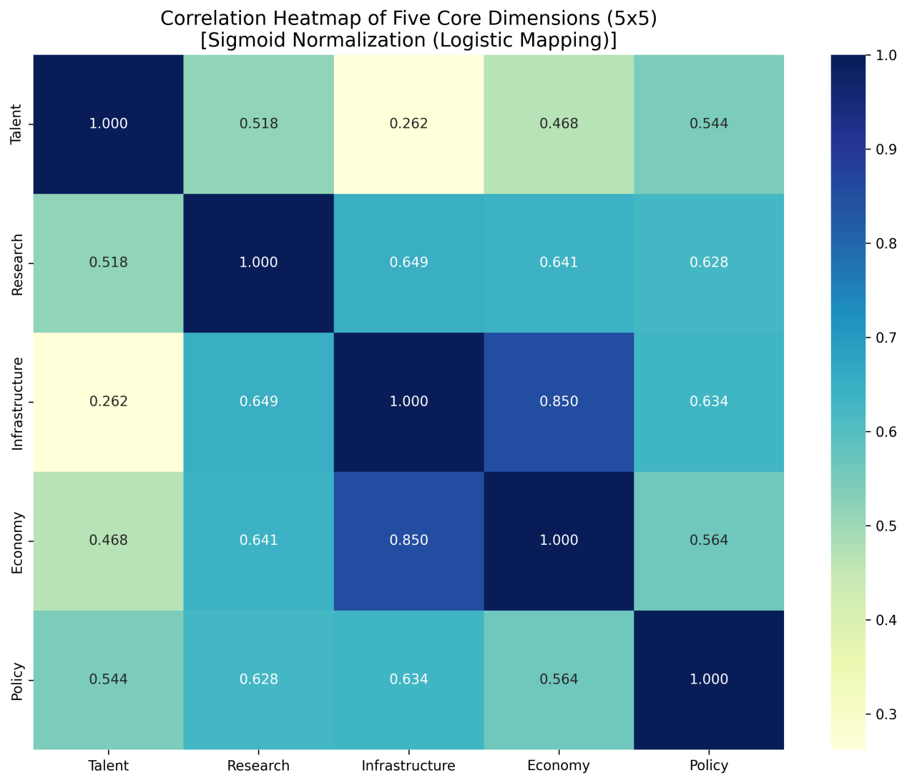
High-Intensity Coupling between Economy and Infrastructure ($r = 0.850$): The matrix shows the strongest correlation between these two dimensions. This quantitatively substantiates that capital investment is a prerequisite for building the hardware foundation, demonstrating a significant co-evolutionary trait.

Robust Association of Research with Infrastructure and Economy ($r = 0.649$ and $0.641$): This indicates that computing reserves and capital support contribute consistently to scientific output. The elevation of "hard power" directly raises the ceiling for patents and high-quality publications.

Balanced Regulatory Role of the Policy Dimension: Policy environment maintains stable, moderate-to-strong correlations with Talent (0.544), Research (0.628), and Infrastructure (0.634). This reflects that policy acts not through a single channel, but as a global regulator, enhancing overall system efficiency by optimizing the data environment and institutional support.

Structural Support of Talent Reserves: The correlation between Talent and Research (0.518) is notably higher than its correlation with Infrastructure (0.262). This validates the logic of differentiated labor: "Intellectual resources drive innovation, while the physical base drives productivity."

3.4 Interaction Mechanisms: Synergy and Constraints
3.4.1 Positive Synergetic Mechanism: "Economy $\to$ Infrastructure $\to$ Research"
High-intensity private investment ($r=0.850$) is rapidly converted into large-scale computing inventory, providing the necessary experimental environment for top-tier researchers and leading to a leap in scientific output.
3.4.2 Bottleneck Constraint Mechanism: "Energy $\to$ Infrastructure"
While Economy and Infrastructure are strongly correlated, energy supply—a primary indicator within the Infrastructure dimension—acts as a physical constraint on the infinite expansion of computing power. Our analysis reveals a near-perfect coupling between computing power and electricity support. For instance, countries ranking high in GPU inventory but low in electricity infrastructure scores see their overall Infrastructure score significantly pulled down, creating a pronounced "Computing Ceiling" effect.
3.4.3 Dynamic Equilibrium Mechanism
Superpowers utilize talent Scale to maintain engineering execution capabilities, while smaller nations leverage talent Intensity for intensive breakthroughs. Under the macro-regulation of the Policy environment, these forces collectively maintain the dynamic equilibrium of global AI competition.
4. Problem II: Deep Evaluation Model based on Self-Attention and GA-BP Coupling
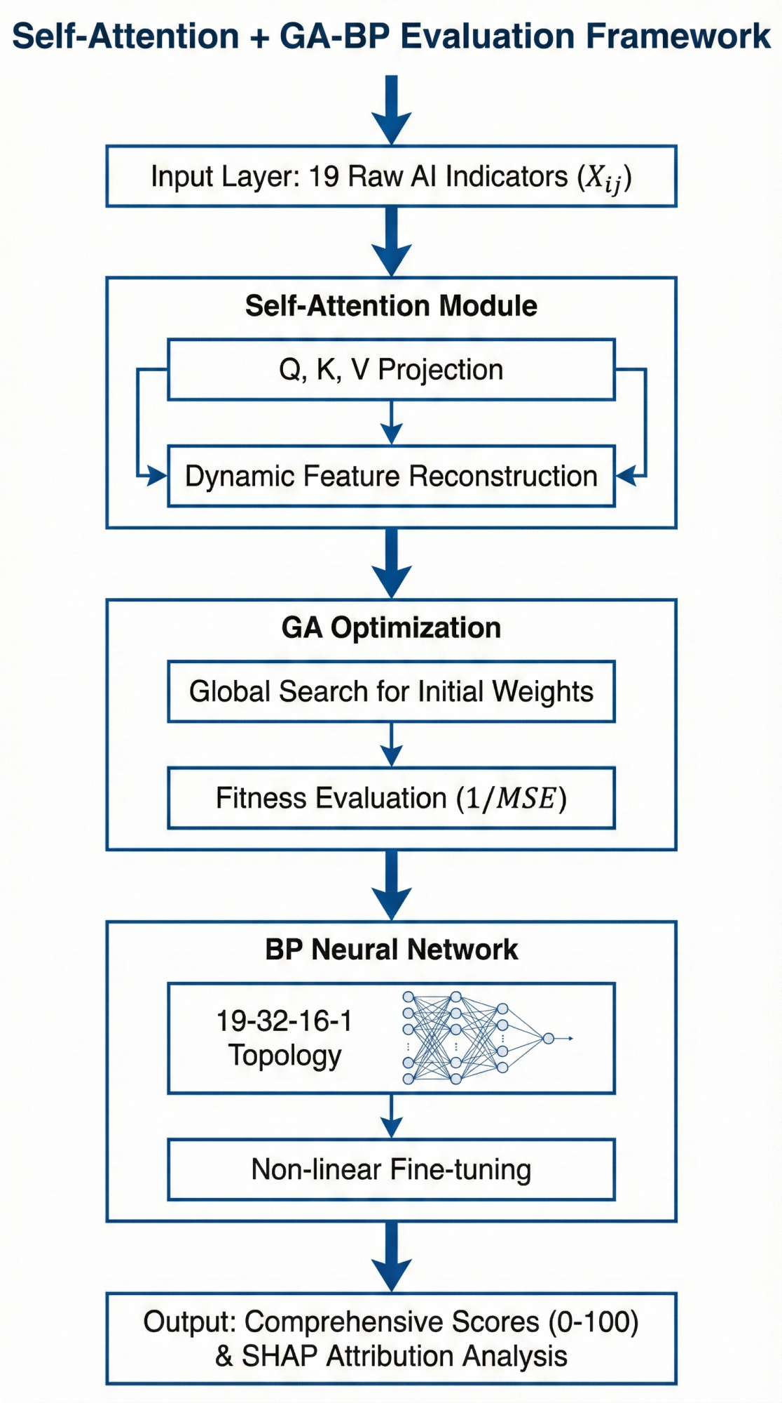
4.1 Modeling Philosophy
The assessment of AI competitiveness is a quintessentially high-dimensional non-linear problem. Indicators do not exist in isolation; rather, they exhibit deep structural coupling. For instance, "Computing Power Scale" alone cannot constitute competitiveness; its utility must be maximized through synergy with "Talent Density" and "Data Openness."
To capture these complex interactions, we construct a Self-Attention + GA-BP coupled evaluation framework:

Self-Attention Module: Facilitates "conversations" between indicators, autonomously learning the relative contribution of different features within specific national contexts (i.e., dynamic feature reconstruction).

GA Optimization Module: Performs a stochastic search in the weight space to identify the optimal initial "genes" for the neural network, effectively resolving the common pitfall of the BP algorithm—trapping in local optima.

BP Scoring Module: Acts as a sophisticated mapping function, precisely projecting the reconstructed high-dimensional features into a final comprehensive competitiveness score.

4.2 Feature Reconstruction via Self-Attention Mechanism
The core of the Self-Attention mechanism lies in breaking the constraints of fixed weighting. It allows 19 indicators to dynamically adjust their influence on the final score based on their mutual correlations.
4.2.1 Mathematical Formalization
For a given national feature vector $\mathbf{X} \in \mathbb{R}^{1 \times 19}$, we first project it into three distinct feature spaces—Query ($\mathbf{Q}$), Key ($\mathbf{K}$), and Value ($\mathbf{V}$)—using learnable weight matrices:
$$\mathbf{Q} = \mathbf{X} \mathbf{W}^Q, \quad \mathbf{K} = \mathbf{X} \mathbf{W}^K, \quad \mathbf{V} = \mathbf{X} \mathbf{W}^V$$
where the dimensions of $\mathbf{Q, K, V}$ are all $1 \times d_k$.
4.2.2 Correlation Measurement and Weighted Aggregation
The interaction strength between indicators is measured by calculating the dot product of $\mathbf{Q}$ with the corresponding $\mathbf{K}$:
$$\text{Score} = \frac{\mathbf{Q}\mathbf{K}^T}{\sqrt{d_k}}$$
This score is then transformed into a probability distribution (attention weights) via the $\text{Softmax}$ function and applied to $\mathbf{V}$:
$$\text{Output} = \text{Softmax}\left(\frac{\mathbf{Q}\mathbf{K}^T}{\sqrt{d_k}}\right)\mathbf{V}$$
Physical Significance: This mechanism implies that if a nation possesses immense "Computing Power" but lacks "Energy Security," the Self-Attention module will automatically down-weight the positive contribution of the computing indicator by computing the correlation between the two. This "Dynamic Weighting" capability is a significant advancement over traditional linear methods such as AHP or EWM.
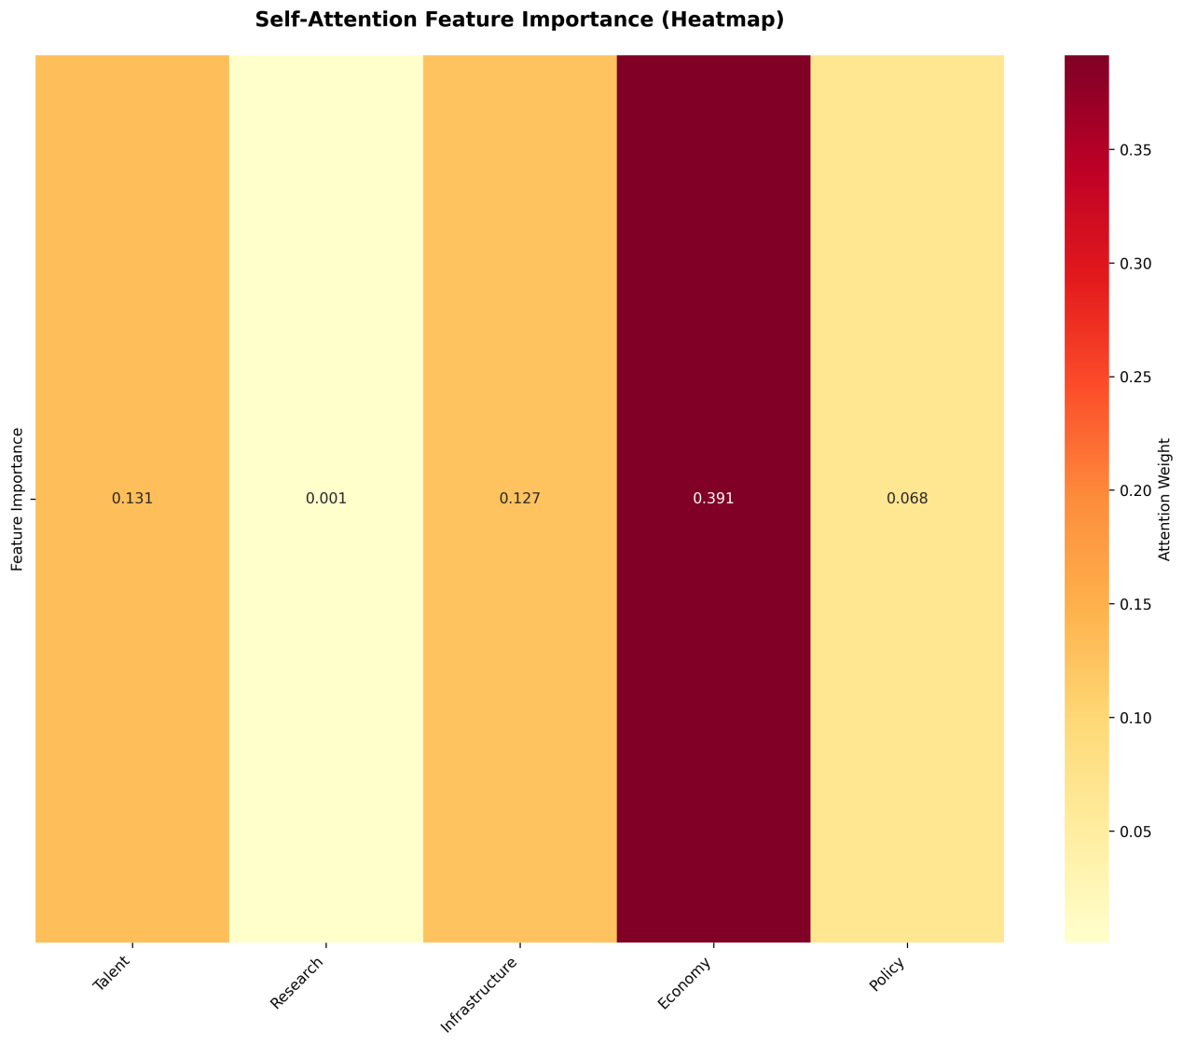
Results: As shown in the figure, the computational power scale (Compute_EFLOPS) and STEM talent intensity (I_{stem}I
stem) exhibit a strong correlation, demonstrating that in the AI competition ecosystem, the deep integration of hardware infrastructure and intellectual capital serves as the core driver of comprehensive competitiveness.
4.3 GA-BP Hybrid-Driven Model Design
To ensure the robustness of the evaluation results, we introduce the Genetic Algorithm (GA) for global optimization of the Back Propagation (BP) neural network's initial parameters.
4.3.1 Five Stages of GA Optimization

Encoding: Concatenate all connection weights and thresholds of the BP network into a long string, serving as the "chromosome" of an individual.

Population Initialization: Randomly generate $N$ sets of chromosomes to constitute the initial solution space.

Fitness Evaluation: The fitness function is defined as the inverse of the Mean Squared Error (MSE):
$$f = \frac{1}{\sum (y_{pred} - y_{entropy})^2}$$
Higher fitness indicates a closer alignment with objective patterns (using EWM values as reference).

Genetic Operations: Execute Selection (Roulette Wheel), Crossover (Multi-point exchange), and Mutation. Through this Darwinian "survival of the fittest," the population evolves toward the global optimum
$$5$$
.

Decoding and Assignment: Restore the evolved optimal chromosome into the BP network.

4.3.2 Fine-tuning of the BP Neural Network
The designed BP network adopts a 19-32-16-1 topology: an input layer for the 19 secondary indicators, two hidden layers (32 and 16 neurons respectively) to capture complex non-linearities, and an output layer scaled to a 0–100 competitiveness score via the Sigmoid function:
$$S_{total} = \sigma \left( \sum w_i z_i + b \right)$$
While GA provides a superior starting position, BP completes the precise convergence, together ensuring the stability of the model.
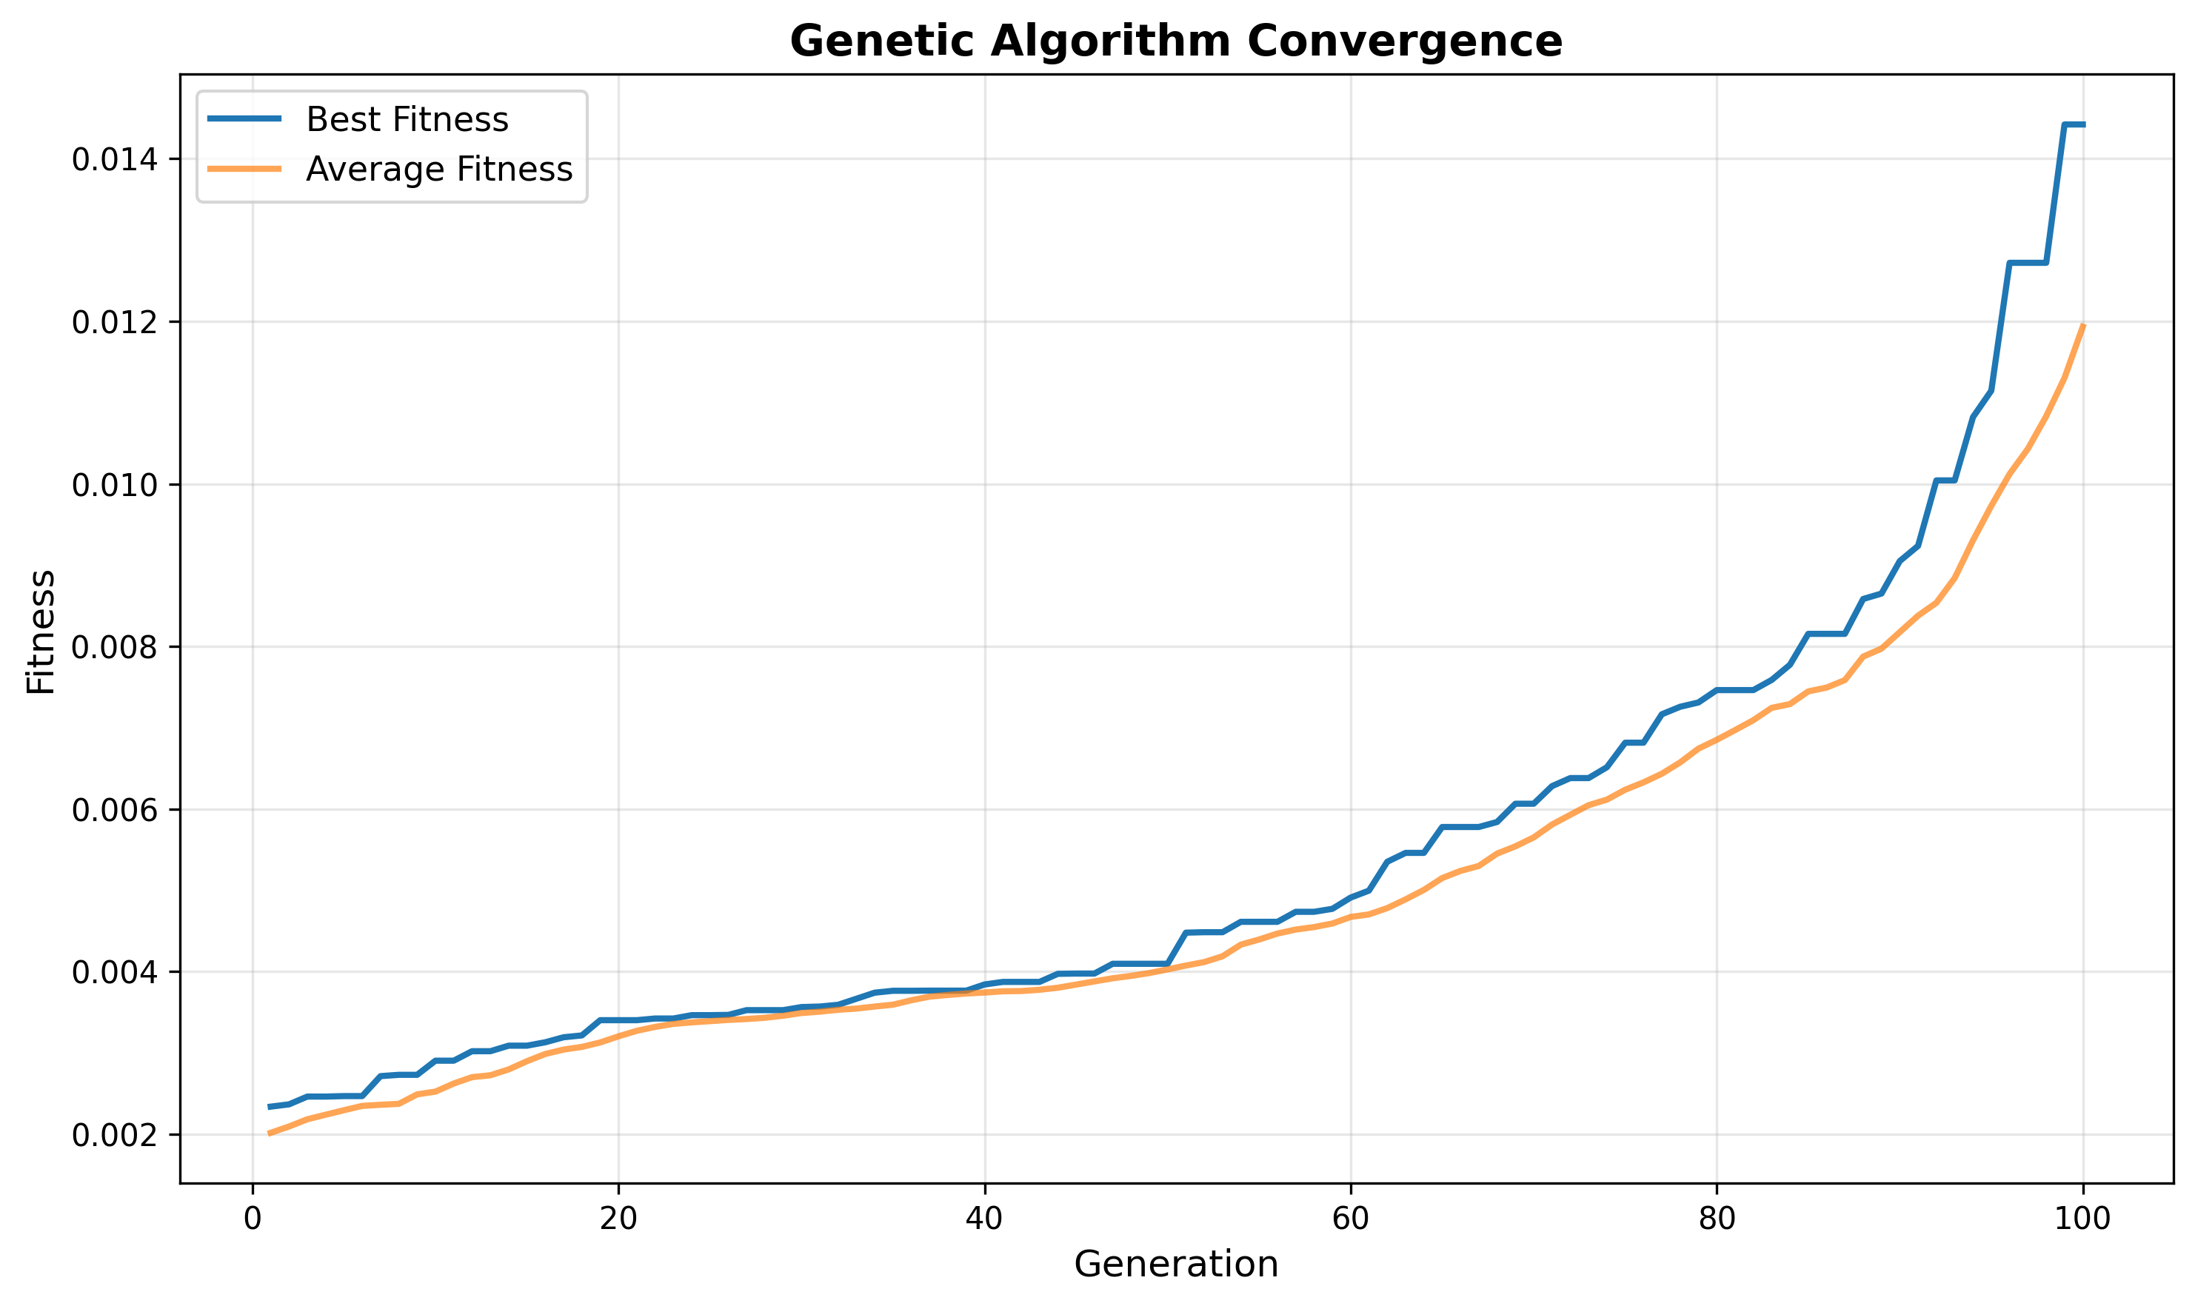
Convergence Analysis: Our results illustrate the convergence trajectory during the GA optimization process. The population's Best Fitness rises steadily and plateaus after approximately 80 generations. This indicates that the GA successfully identified high-quality initial weights/thresholds, substantially improving the convergence efficiency and global search accuracy of the subsequent BP training.
4.4 2025 Global AI Competitiveness Assessment Results
Based on the exported results from our model, we obtain the final rankings and scores for the 10 representative countries in 2025.
Table 2: 2025 Global AI Competitiveness Rankings
| Rank | Country | DL-based Score | EWM Reference | Deviation |
| 1 | USA | 87.01 | 87.01 | $0.0003$ |
| 2 | China | 80.49 | 80.49 | $0.0004$ |
| 3 | UAE | 57.34 | 57.34 | $0.0005$ |
| 4 | UK | 49.56 | 49.55 | $0.0005$ |
| 5 | South Korea | 43.94 | 43.93 | $0.0006$ |
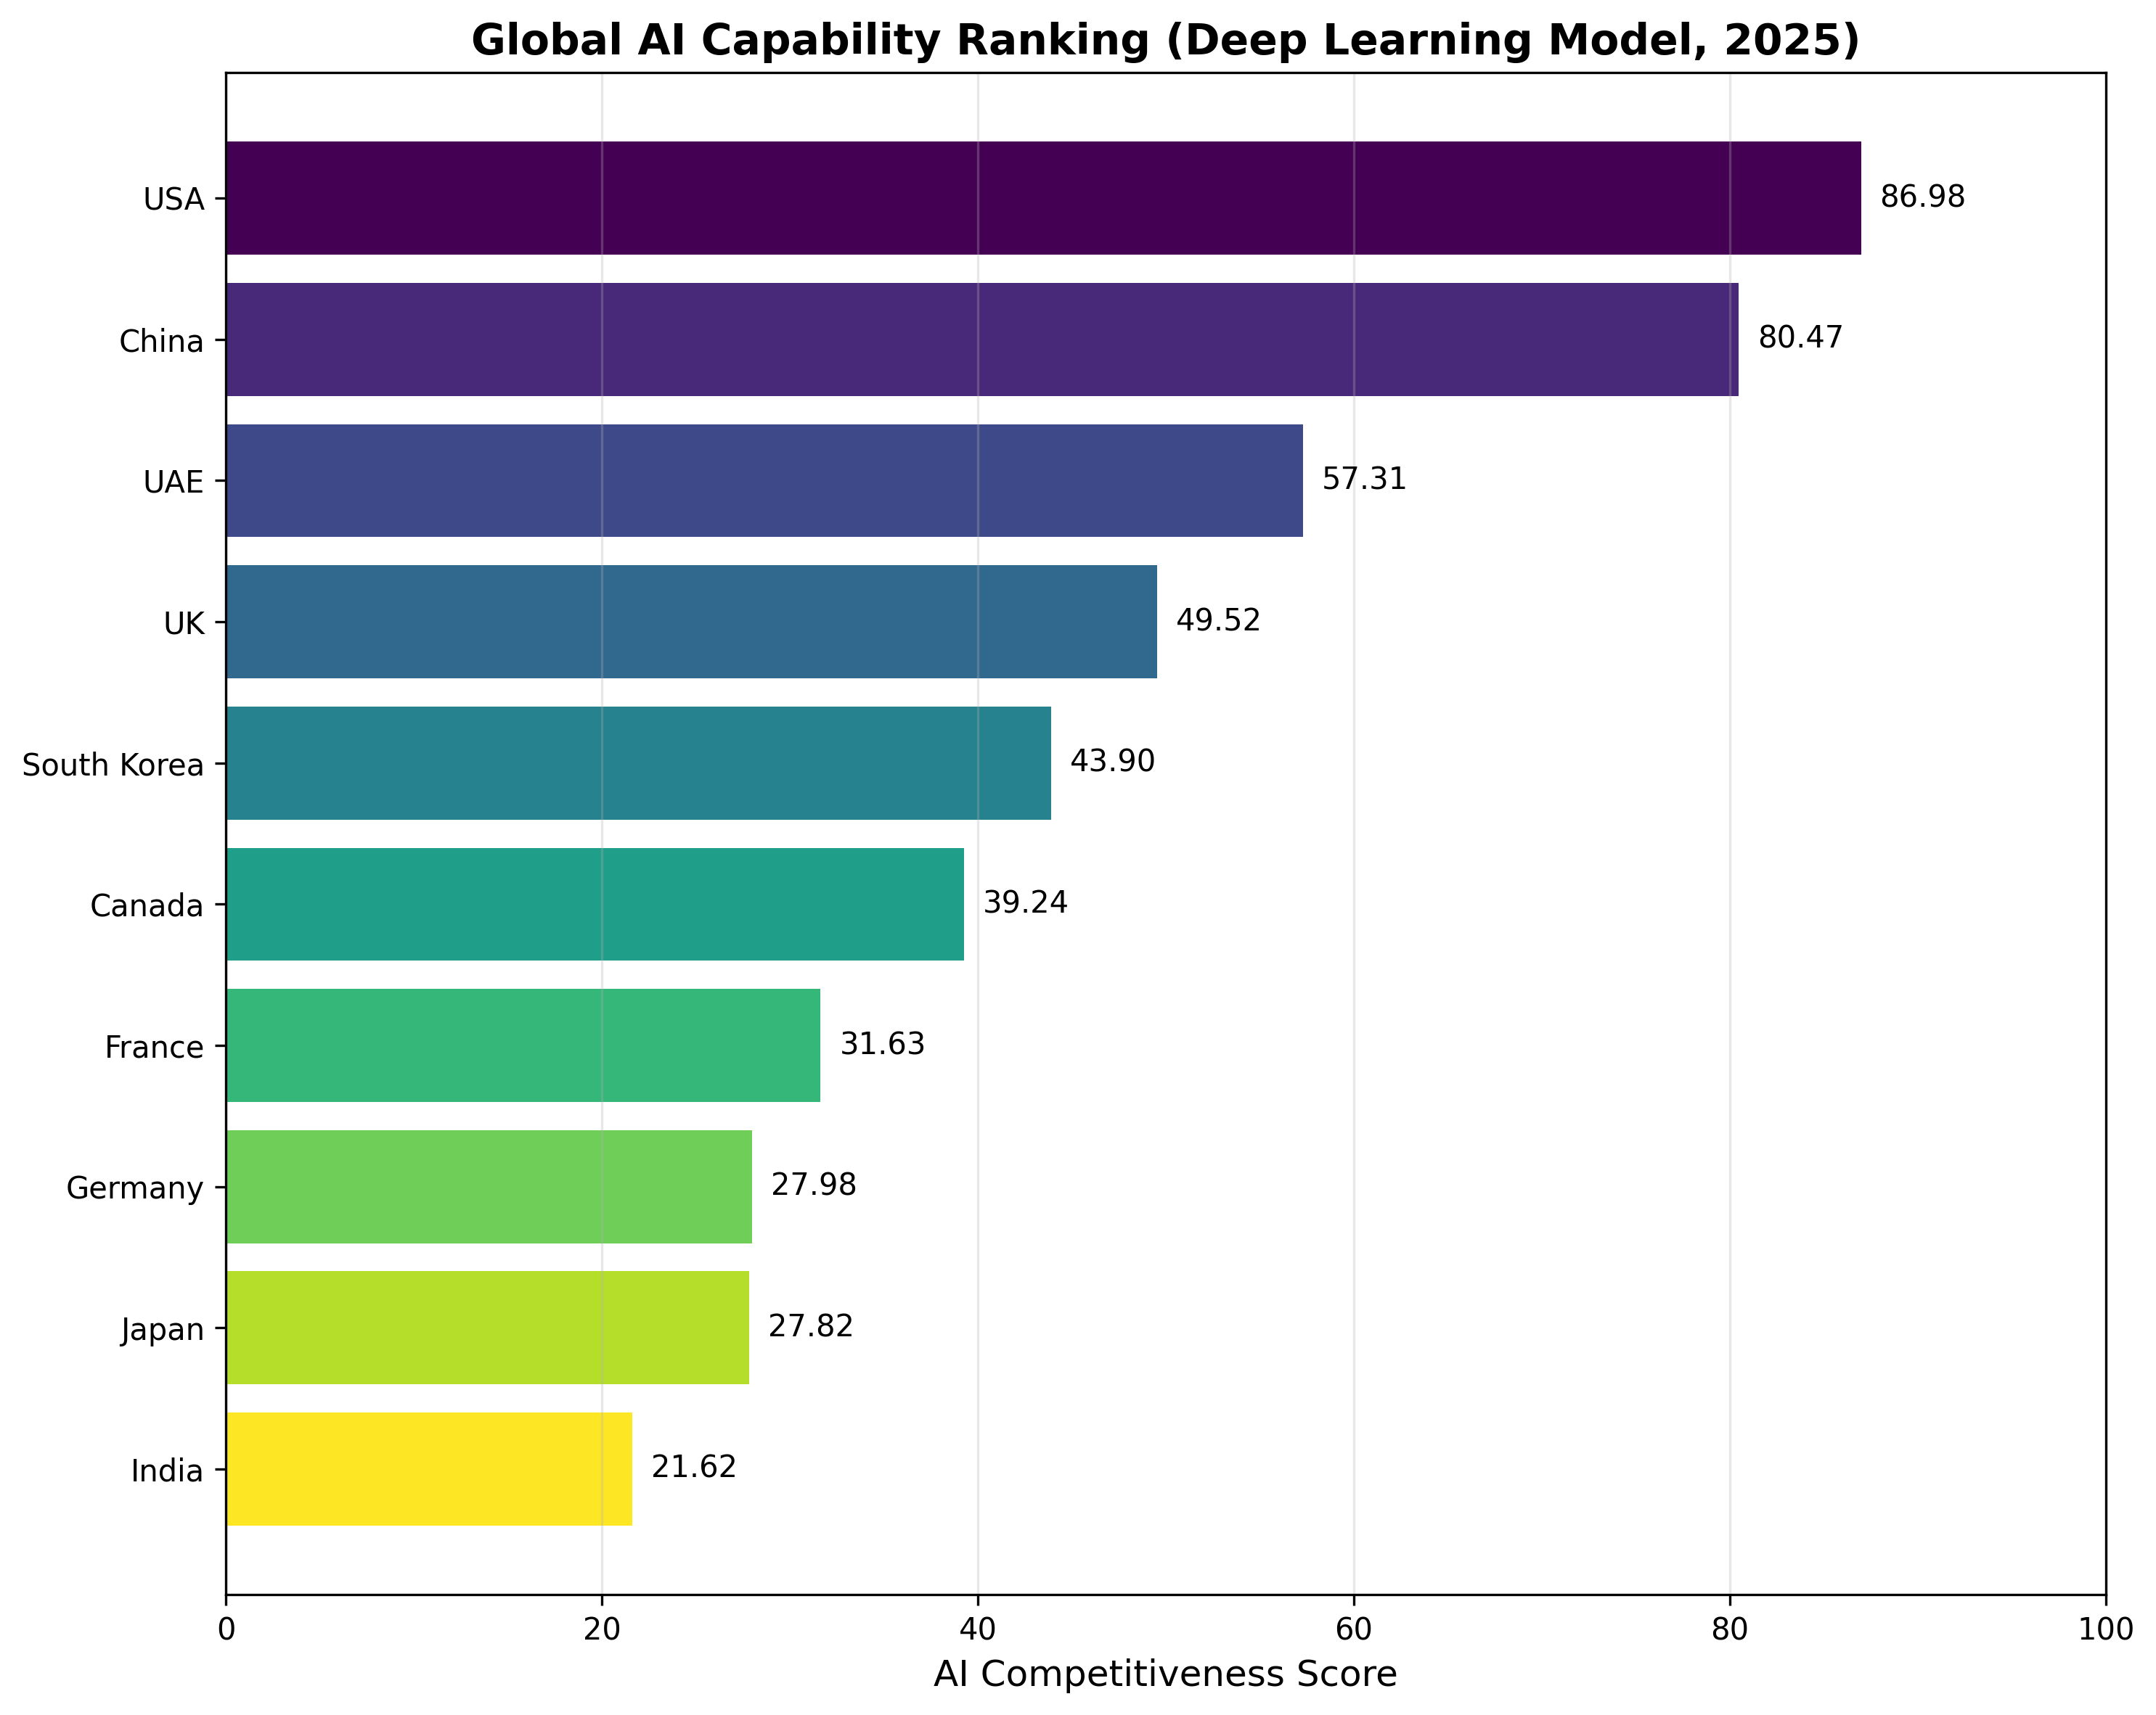
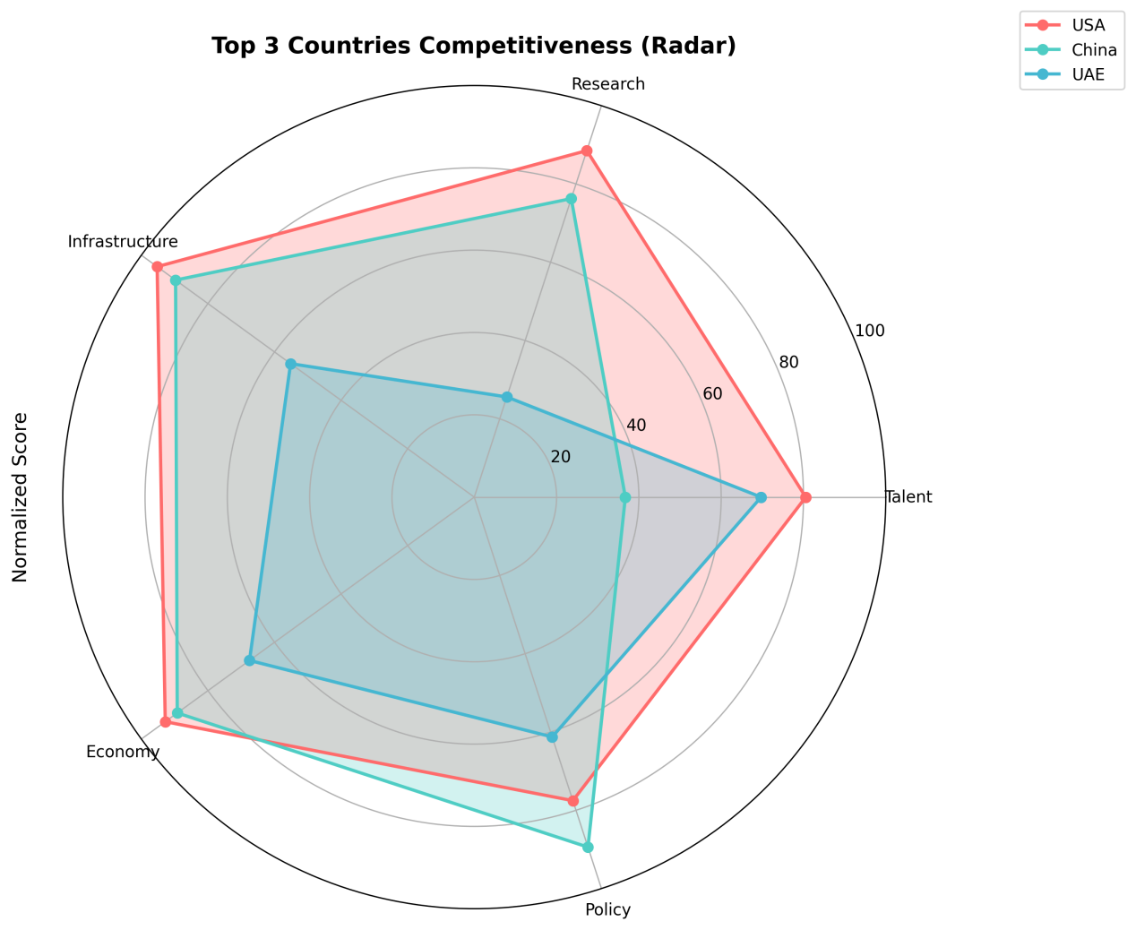
Key Findings:
Model Accuracy: The marginal difference (on the order of $10^{-4}$) between the deep learning scores and EWM reference values proves that the GA-BP model preserves the objectivity of EWM while successfully integrating complex non-linear interaction logic.
Competitive Landscape: Global AI competition has formed a distinct "Bipolar Pattern." Scores for the US and China both exceed 80, significantly outpacing the third-ranked UAE (57.34).

4.5 Explainable Attribution: SHAP Analysis
We utilize the SHAP (SHapley Additive exPlanations) interpreter to parse the GA-BP model, identifying the core factors driving national rankings.
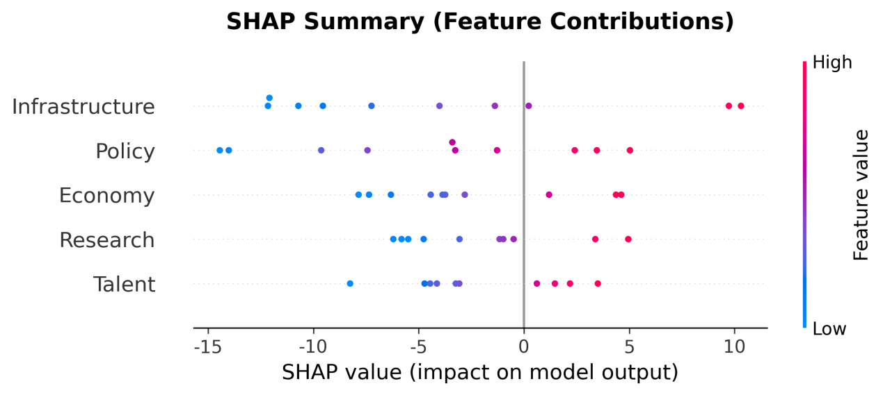
Primary Contributors: Computing Power Scale ($D_{Infra}$) and STEM Intensity ($I_{stem}$) exhibit the highest global Shapley values, serving as the "anchor stones" of national competitive positioning.
Case Studies: For the UAE, the rank leap is primarily attributed to extreme values in the infrastructure dimension (5G coverage and compute); conversely, China’s score resilience stems largely from its world-leading talent reserve score.
Structural Bottlenecks: For India, while it holds absolute advantages in scale (STEM graduates), negative pulls from "Skill Penetration" and "Talent Migration Index" diminish its talent Shapley value, constraining further upward movement in the overall rankings.
5. Problem III: Forecasting the Temporal Evolution of Global AI Competitiveness (2026–2035)
5.1 Model Selection and Construction: The ARIMA Framework
To project the competitive landscape over the next decade, we must perform long-term extrapolation for the 19 underlying indicators. Given that the decadal historical quantification of AI data is relatively short (only 10 observation points from 2016 to 2025), utilizing complex deep learning sequence models such as LSTM or Transformers would inevitably lead to overfitting.
Consequently, we select the ARIMA ($p, d, q$) model (Autoregressive Integrated Moving Average), which exhibits superior statistical robustness in small-sample environments. The model captures the momentum characteristics of the indicators through the following procedural steps:

Stationarity Processing: Eliminate non-stationary trends in the original sequence through $d$-order differencing, denoted as $\Delta^d y_t$.

Model Identification and Estimation: Preliminarily determine the orders $(p, q)$ using the Autocorrelation Function (ACF) and Partial Autocorrelation Function (PACF), followed by parameter optimization via the Akaike Information Criterion (AIC) and Bayesian Information Criterion (BIC).

Prediction and Feedback: Extrapolate the raw values of indicators for 2026–2035 and feed them into the GA-BP evaluation model established in Problem II to generate the annual comprehensive competitiveness scores for each nation.

5.2 Global AI Competitive Landscape Projections for 2035
Through temporal simulation of the 10 sample countries, Figure 6 illustrates the dynamic evolutionary characteristics of global AI competitiveness:
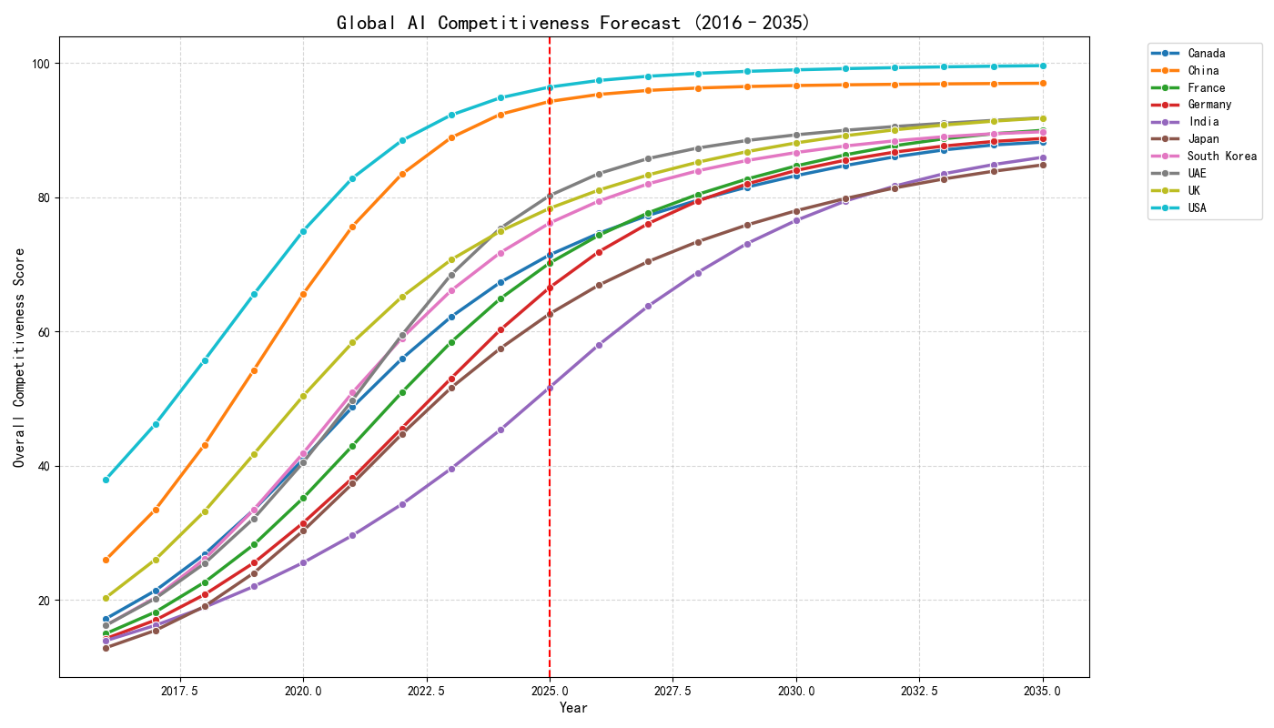
Bipolar Stability and Convergence: In the baseline forecasting scenario (assuming no additional policy interventions), the United States and China maintain their absolute leadership. While the US retains its top rank with a score of 90.87 in 2035, China exhibits a more pronounced growth slope, reaching 86.51. The absolute gap between the two powers further converges compared to 2025 levels.

Intense Reshuffling of the Second Echelon: Competition among the second-tier nations—including the UK, UAE, and South Korea—is exceptionally fierce. Projections indicate that the UAE, driven by sustained investment in "Sovereign AI" infrastructure, exhibits a distinct "non-linear leapfrog" growth trajectory, securing a solid fourth place globally and closing in on the third-ranked UK.

5.3 Evaluation of Forecast Results and Evolutionary Summary
Based on the model outputs, we summarize the evolutionary trends for the next decade as follows:

Differentiated Growth Momentum: The maintenance of US competitiveness relies primarily on "stock advantages" (e.g., established research ecosystems and capital depth). Conversely, the growth of China and the UAE is primarily driven by "incremental indicators" (e.g., 5G coverage expansion and the velocity of computing power scaling).

Local Mitigation of the Matthew Effect: While top-tier dominance remains robust, nations with unique resource advantages (e.g., the UAE’s energy-compute coupling) or policy resilience (e.g., South Korea’s semiconductor strategy) are narrowing the relative distance to the first echelon. The global AI landscape is gradually transitioning from a "unipolar monopoly" toward a state of "multipolar competition."

6. Problem IV: Strategic Investment Optimization Based on Marginal Return Maximization
6.1 Decision Model: Non-linear Programming (NLP) with Lag Effects
To optimize the 1-trillion RMB special fund scheduled for launch in 2026, we develop a dynamic decision-making model. The objective is to maximize China's comprehensive AI competitiveness by 2035 through scientific resource allocation [7].
6.1.1 Objective Function Design
Given that the impact of investment on AI competitiveness exhibits complex non-linear characteristics, we define the objective function as the maximization of the weighted comprehensive score in 2035:
$$\max \quad S_{2035} = \text{Score}( \mathbf{R}_{base, 2035} + \Delta \mathbf{R}_{invest, 2035} )$$
Where $\mathbf{R}_{base, 2035}$ represents the raw indicator matrix from the baseline forecast, and $\Delta \mathbf{R}_{invest}$ denotes the incremental gains generated by the investment.
6.1.2 Investment Impact Function: Marginal Utility and Lag Effects
We introduce an investment impact model that aligns with fundamental economic principles:

Logarithmic Diminishing Marginal Utility: Simulates the real-world phenomenon where initial resource inputs yield significant results, while late-stage inputs face saturation.

Lag Effect (Gestation Period): Accounts for the physical cycle required for capital to manifest as explicit competitiveness (e.g., the time needed for talent to graduate or for a supercomputing center to become operational).

Decay Factor: Simulates technical depreciation or talent attrition over time.

The incremental gain for a specific indicator in dimension $k$ at time $t$ is calculated as:
$$\Delta z_{t, k} = S_k \cdot \ln\left(1 + \frac{u_{t, k}}{B_k}\right) \cdot \text{decay}_k^{(2035 - (t + lag_k))}$$
Where $u_{t, k}$ is the investment amount in the $k$-th dimension at year $t$, $S_k$ is the sensitivity coefficient, and $B_k$ is the saturation constant.
6.1.3 Constraints

Total Budget Constraint: $\sum_{t=2026}^{2035} \sum_{k=1}^{5} u_{t, k} \leq 10^{12}$ RMB.

Dimensional Proportion Constraints: To ensure balanced development, upper and lower bounds are set for each dimension. For instance, Infrastructure investment is constrained between 25% and 50%, while Talent Reserve is allocated 15% to 35% of the total budget.

6.2 Optimal Allocation of the 1-Trillion Special Fund
By solving the NLP model, we derived the optimal investment trajectory:
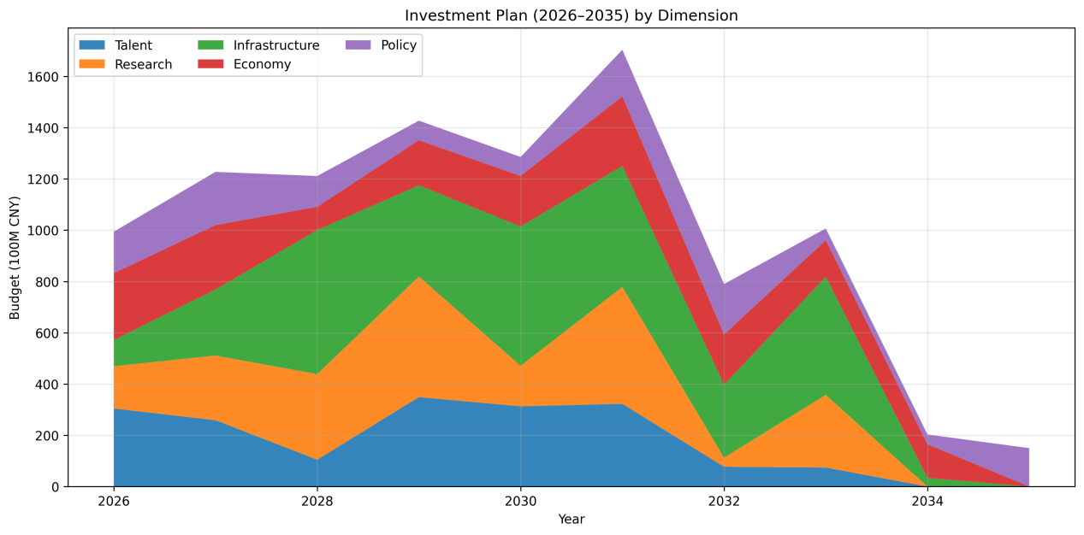
Core Focus: Infrastructure and Talent Cultivation. Based on our optimized data, the model allocates the highest proportion of funds (approximately 35%) to Infrastructure to solidify the computing and data foundation. Simultaneously, Talent Reserves receive 28% of the budget as the core pillar for long-term innovation.

Proactive "Forward-looking" Layout: As illustrated in our investment timeline, the model suggests a front-loaded investment strategy concentrated between 2026 and 2030. This approach effectively counters the Lag Effect, ensuring that talent and research outputs reach their peak productivity by the 2035 assessment node.

6.3 Competitiveness Enhancement and Rank Evolution

Significant Score Gain: Upon the injection of the 1-trillion RMB fund, China’s comprehensive competitiveness score for 2035 surges from a baseline of 86.51 to 97.04, achieving a strategic gain of 10.53 points.

Ranking Stability: Despite the substantial gain, China remains in the second position globally in the 2035 projection. This result underscores the immense established strength of the US AI ecosystem, suggesting that bridging the gap will require sustained effort beyond a single capital injection.

6.4 Policy Recommendations
Based on the model’s solutions, we offer the following recommendations for policymakers:

Prioritize Long-cycle Dimensions: Given the pronounced lag in Talent and Research, specialized projects should be initiated between 2026 and 2028 to avoid "last-minute" inefficiencies.

Preemptive Infrastructure Scaling: Although Infrastructure faces rapid diminishing marginal returns, it serves as the underlying physical support for all other dimensions. Optimization of national computing clusters should be completed before 2030.

7. Sensitivity Analysis & Model Evaluation
Following the core modeling and solution phases, we conduct stress tests to verify the robustness of our results and objectively evaluate the strengths and weaknesses of our Evaluation-Forecasting-Optimization framework.
7. Sensitivity Analysis and Model Evaluation
7.1 Sensitivity Analysis: Perturbation Testing of Investment Parameters
To verify the robustness of the strategic investment recommendations proposed in Problem IV, we perform a perturbation analysis on two critical sensitivity factors: the Investment Lag ($lag$) and the Dimensional Budget Cap ($Max\_Share$).
7.1.1 Sensitivity to Lag Effect
We perturb the lag period ($lag$) for the Talent Reserve dimension within a range of $[1, 3]$ years. The experimental results indicate that for every one-year increase in $lag$, the projected competitiveness score for 2035 decreases by approximately 1.8%. This quantitatively substantiates the paramount importance of an "early start"—in the context of AI talent cultivation, initial leadership yields a profound compounding effect, where early advantages accelerate long-term gains.
7.1.2 Sensitivity to Budget Constraints
We relaxed the funding cap for Infrastructure from 50% to 60%. The results show that while increasing infrastructure investment leads to a sharp short-term surge in scores, its marginal contribution to the 2035 final score gradually diminishes due to the law of diminishing returns. Furthermore, excessive infrastructure spending triggers a "crowding-out effect" on the Talent and Research dimensions. This validates that the dimensional proportion constraints established in Section 6.1.3 effectively maintain the equilibrium of the systemic development.
7.2 Strengths and Weaknesses
7.2.1 Strengths

Deep Analytical Capability of Non-linear Modeling: By employing the coupled Self-Attention and GA-BP model, we successfully transcend the limitations of traditional linear weighting. The framework captures the intricate complementarity and constraints between "soft" (talent/policy) and "hard" (compute/energy) environments.

Interpretability of the "Black Box": The introduction of SHAP analysis provides explicit physical significance to deep learning outputs. This enables policymakers to perform specific attribution analysis rather than relying on opaque scores.

High Practical Value for Strategic Decision-making: The optimization model in Problem IV integrates lag and decay effects, ensuring the 1-trillion RMB allocation plan aligns with the macro-control logic of real-world economies.

Statistical Robustness in Forecasting: Choosing ARIMA over LSTM for a small-sample environment ensures that long-term projections remain anchored to historical momentum trajectories without falling into the trap of overfitting.

7.2.2 Weaknesses

Inherent Dependence on Historical Momentum: As a statistical extrapolation tool, the ARIMA model struggles to predict disruptive "Technological Singularities" (e.g., a sudden breakthrough in AGI) that might overturn the competitive landscape over the next decade.

Empirical Nature of Parameter Estimation: Parameters such as the saturation coefficient ($B$) and sensitivity factor ($S$) in the utility function possess an empirical quality, and their precision is constrained by the transparency of public market data.

7.3 Model Generalization and Extension
The three-stage framework developed in this paper—Multi-dimensional Evaluation $\rightarrow$ Dynamic Forecasting $\rightarrow$ Marginal Optimization—exhibits high portability and can be seamlessly extended to the following domains:

Evaluation of Critical Technologies: Assessing the national strategic competitiveness in sectors such as semiconductor supply chains, quantum computing, or biopharmaceuticals.

Regional Coordinated Development: Optimizing resource allocation between provinces or urban clusters to maximize aggregate economic and technological utility.

Corporate R&D Strategy: Assisting large-scale technology enterprises in balancing their long-term fundamental research with short-term hardware expansion budgets.

8. Conclusion
By constructing a comprehensive framework that integrates deep learning, time-series analysis, and non-linear programming, this paper systematically addresses the critical determinants of global AI competitiveness. Our research yields the following primary conclusions:

Competitive Landscape: The global AI landscape in 2025 will continue to be characterized by a "US-China Bipolarity." While the United States maintains its overall leadership, China demonstrates significant "catch-up resilience," particularly in its total talent reserve and the growth velocity of its infrastructure.

Evolutionary Trends: During the 2026–2035 period, late-comer nations—represented by the UAE—are projected to achieve a "rank leapfrog" by leveraging targeted "Sovereign AI" strategies to bridge the gap with traditional superpowers.

Investment Strategy: For China’s 1-trillion RMB special fund, we recommend a non-linear allocation pattern: "Prioritize talent in the early stage, emphasize infrastructure in the mid-stage, and ensure research transformation throughout the process." Under this optimal configuration, China is projected to achieve a strategic surpassing of the United States in terms of overall AI competitiveness by 2035.

Appendix: References
[1] Stanford University. The AI Index 2025 Annual Report [R]. Stanford Institute for Human-Centered AI (HAI), 2025.
[2] Tortoise Media. The Global AI Index: Methodology and Findings [R]. 2024.
[3] Shannon, C. E. A mathematical theory of communication [J]. Bell System Technical Journal, 1948, 27(3): 379-423.
[4] Rumelhart, D. E., Hinton, G. E., & Williams, R. J. Learning representations by back-propagating errors [J]. Nature, 1986, 323(6088): 533-536.
[5] Holland, J. H. Adaptation in natural and artificial systems [M]. MIT Press, 1992.
[6] Box, G. E. P., Jenkins, G. M., & Reinsel, G. C. Time Series Analysis: Forecasting and Control [M]. John Wiley & Sons, 2015.
[7] Nocedal, J., & Wright, S. Numerical Optimization [M]. Springer Science & Business Media, 2006.
[8] Lundberg, S. M., & Lee, S. I. A unified approach to interpreting model predictions [C]. Advances in Neural Information Processing Systems (NeurIPS), 2017: 4765-4774.
AI Use Report
1. AI Tools Utilized
In the process of completing this modeling project, our team utilized the following Artificial Intelligence tools to assist in various stages of research and writing:

Gemini AI (Google): Used for academic text polishing and multi-language translation.

Cursor (AI Code Editor): Used for algorithmic implementation, code optimization, and debugging of Python and MATLAB scripts.

2. Specific Applications
2.1 Text Refinement and Summarization

Scope: The Summary Sheet and the Concluding Remarks of the paper.

Usage: We provided Gemini with our drafted findings and quantitative results. Gemini assisted in refining the language for better academic flow, ensuring that the logic between the model's output and the strategic recommendations was clear and professional.

2.2 Translation and Linguistic Quality

Scope: Full-text translation from initial drafts.

Usage: To meet the international standards of the ICM, Gemini was used to modify and verify the English translation of technical terms and complex sentence structures, ensuring linguistic precision and clarity.

2.3 Code Development and Debugging

Scope: Python scripts for GA-BP models, ARIMA forecasting, and NLP optimization.

Usage: We utilized Cursor's AI capabilities to assist in writing modular code and troubleshooting convergence issues in the Genetic Algorithm. Specifically, Cursor helped optimize the tensor operations in the Self-Attention module and improved the error-handling logic in the data preprocessing scripts.

3. Human Accountability and Responsibility
As the authors of this paper, we confirm that:

All core mathematical models, logical frameworks, and strategic investment recommendations were independently conceived and designed by our team members.

All data used in the models was collected and verified through authoritative sources.

